Project Design Phase
Problem – Solution Fit Template

Date | 9 July 2026
Team ID
Project Name | ShopEZ
Maximum Marks | 2 Marks

Introduction
Before developing ShopEZ, we analyzed the problems faced by online shoppers and sellers. The Problem–Solution Fit Canvas helped us understand user needs, identify the root causes of existing challenges, and design a solution that addresses them effectively.
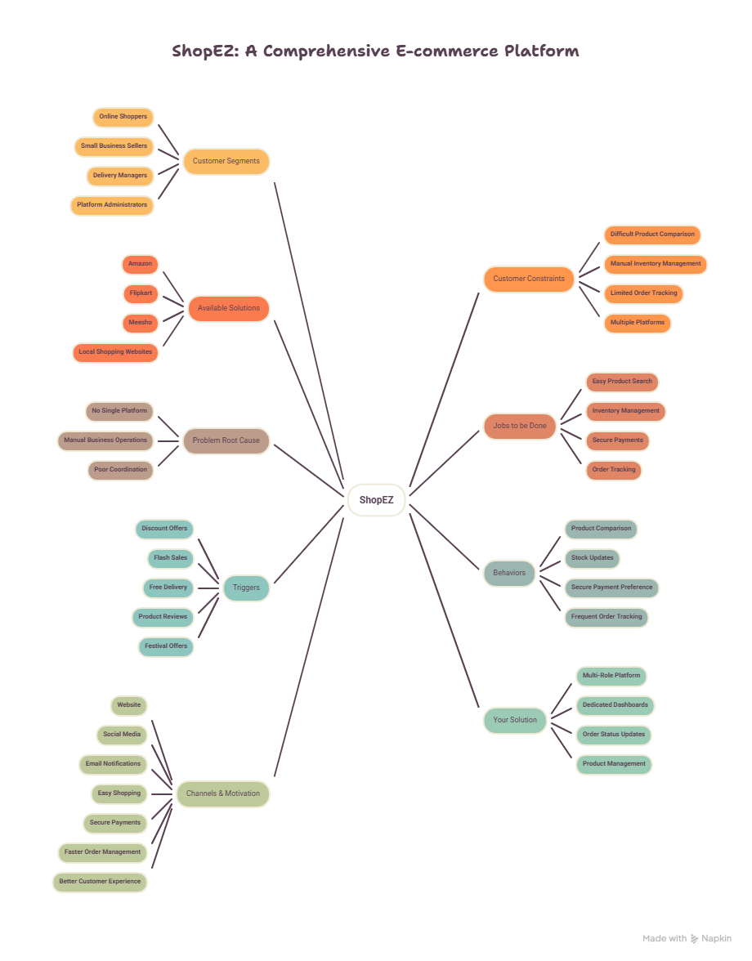
1. Customer Segments
Online shoppers
Small business sellers
Delivery managers
Administrators
2. Customer Constraints
Difficult to compare products.
Manual inventory management.
Limited order tracking.
Time-consuming shopping experience.
3. Available Solutions
Amazon
Flipkart
Meesho
Local shopping websites
4. Jobs to be Done / Problems
Buy products easily.
Manage inventory.
Process orders efficiently.
Track deliveries.
Make secure payments.
5. Problem Root Cause
Multiple platforms for different tasks.
Manual business operations.
Lack of centralized management.
Poor communication between users.
6. Behaviors
Customers compare prices before buying.
Sellers update stock frequently.
Users prefer secure payment methods.
Customers check reviews before purchasing.
7. Triggers
Discount offers
Festival sales
Free shipping
Product ratings
Cashback offers
8. Your Solution
ShopEZ is a centralized MERN-based e-commerce platform that provides role-based dashboards for customers, sellers, delivery managers, and administrators. It simplifies shopping, inventory management, order processing, secure payments, and delivery tracking through a single application.
9. Channels & Motivation
Channels
Website
Social Media
Email Notifications
Motivation
Easy shopping
Secure payments
Better user experience
Efficient order management

Conclusion
The Problem–Solution Fit Canvas helped us understand the expectations of different users and identify practical solutions to their challenges. Based on this analysis, ShopEZ was designed to provide a secure, user-friendly, and centralized platform that improves the online shopping experience while simplifying business operations for sellers and administrators.

